Week 8: Jenkins Automation
- Hands-on practice on manual creation of Jenkins pipeline using Maven projects from Github
- Create the job and build the pipeline for maven-java and maven-web project.
- Questions on Jenkins
- Upload the Screenshots.

- Steps for MavenJava Automation:
Maven Java Automation Steps:
Step 1: Open Jenkins (localhost:8080)
├── Click on "New Item" (left side menu
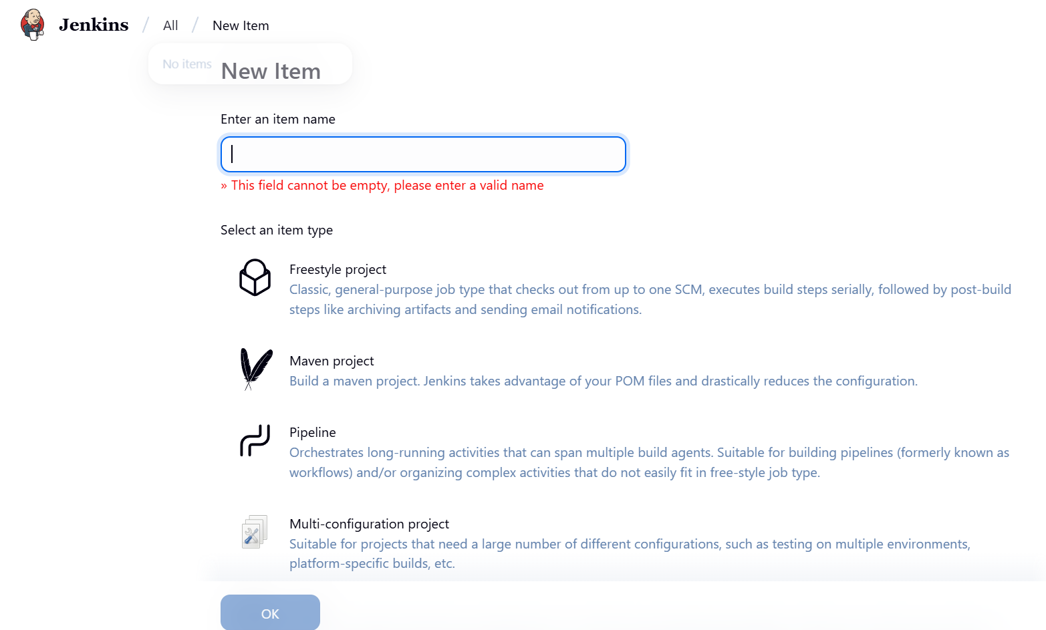

Step 2: Create Freestyle Project (e.g., MavenJava_Build)
├── Enter project name (e.g., MavenJava_Build)
├── Click "OK"
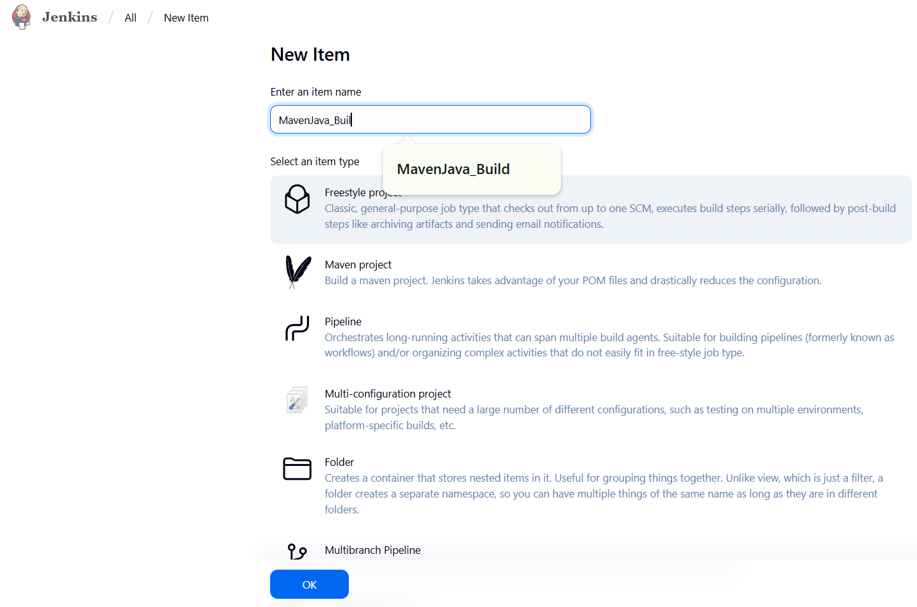
└── Configure the project:
├── Description: "Java Build demo"
├── Source Code Management:
└── Git repository URL: [GitMavenJava repo URL]
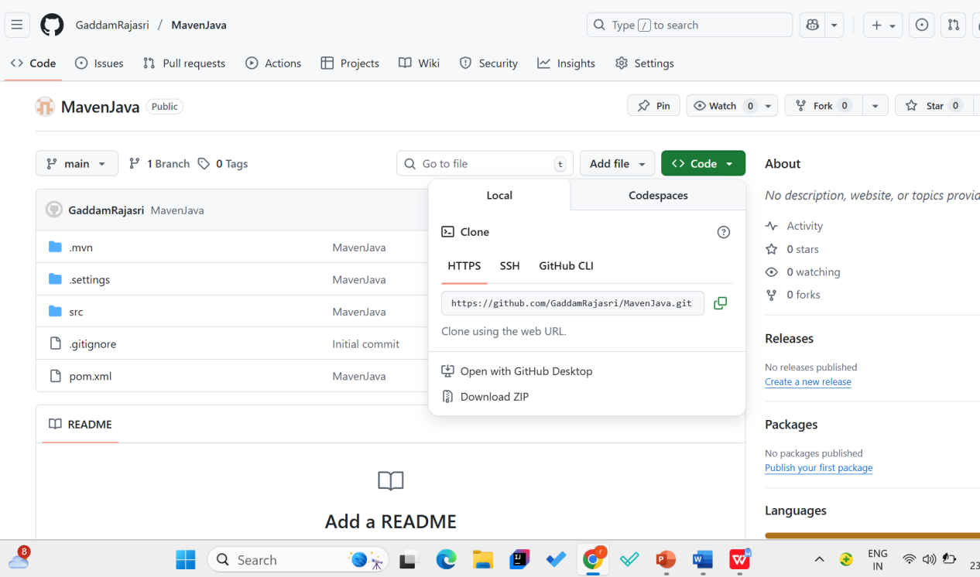
├── Branches to build: */Main or */master
└── Build Steps:
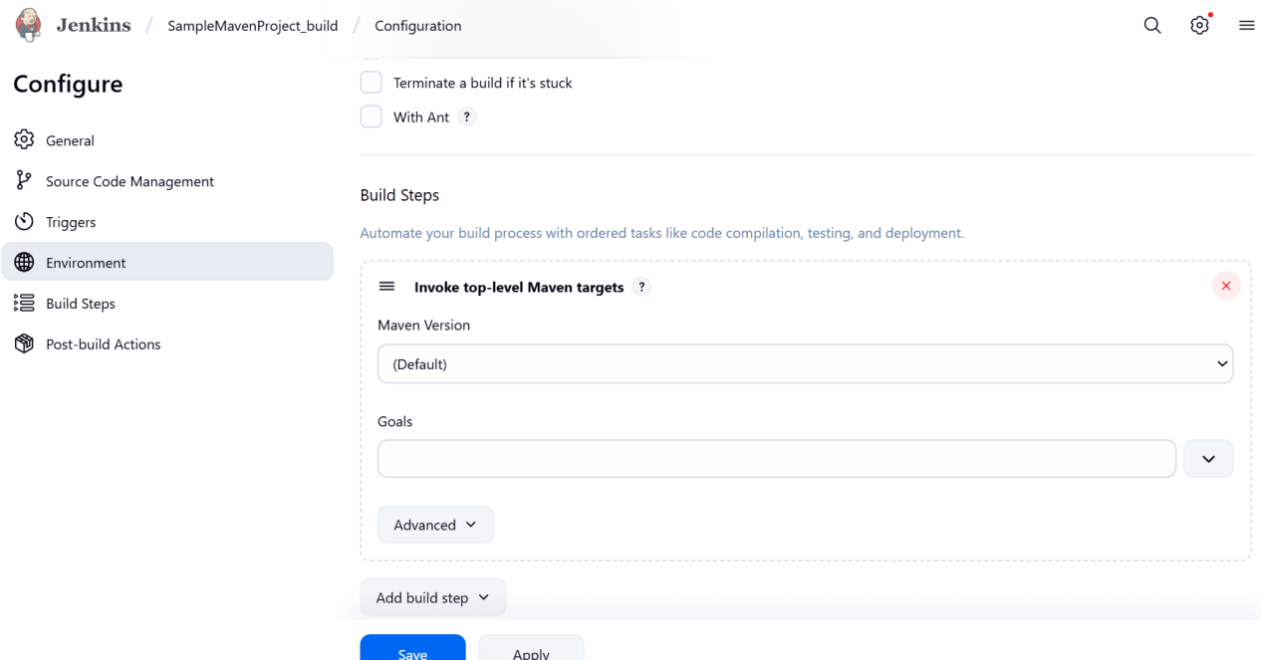
├── Add Build Step -> "Invoke top-level Maven targets"
└── Maven version: MAVEN_HOME
└── Goals: clean
├── Add Build Step -> "Invoke top-level Maven targets"
└── Maven version: MAVEN_HOME
└── Goals: install
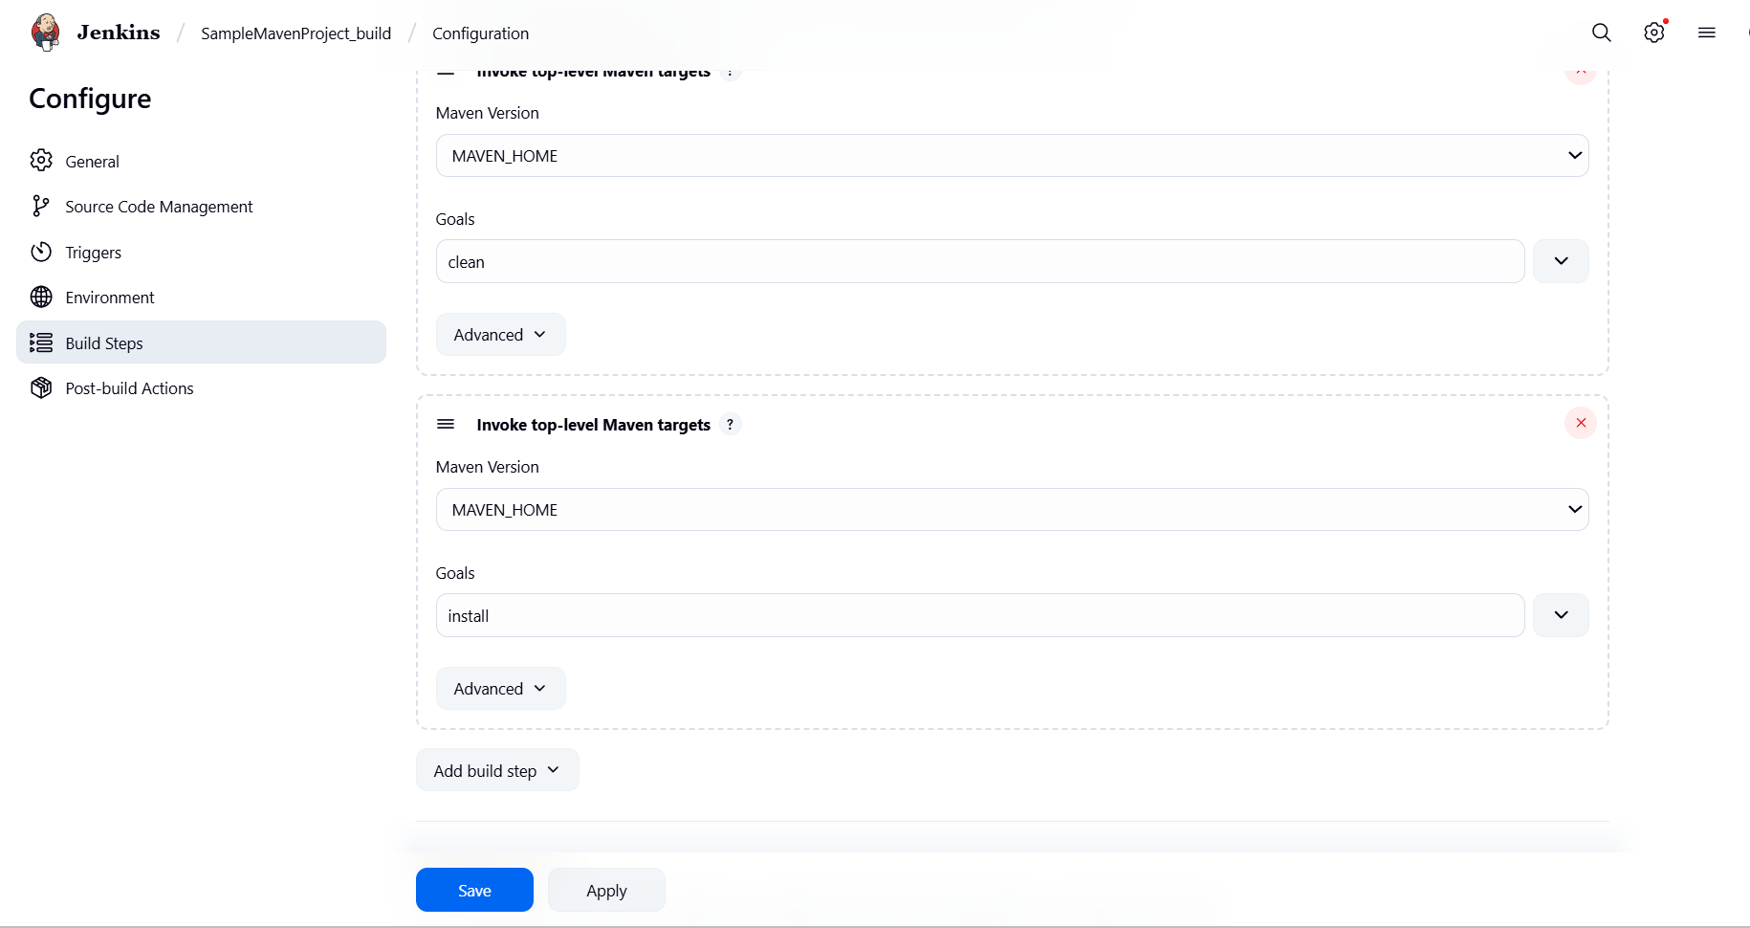
└── Post-build Actions:
├── Add Post Build Action -> "Archive the artifacts"
└── Files to archive: **/*
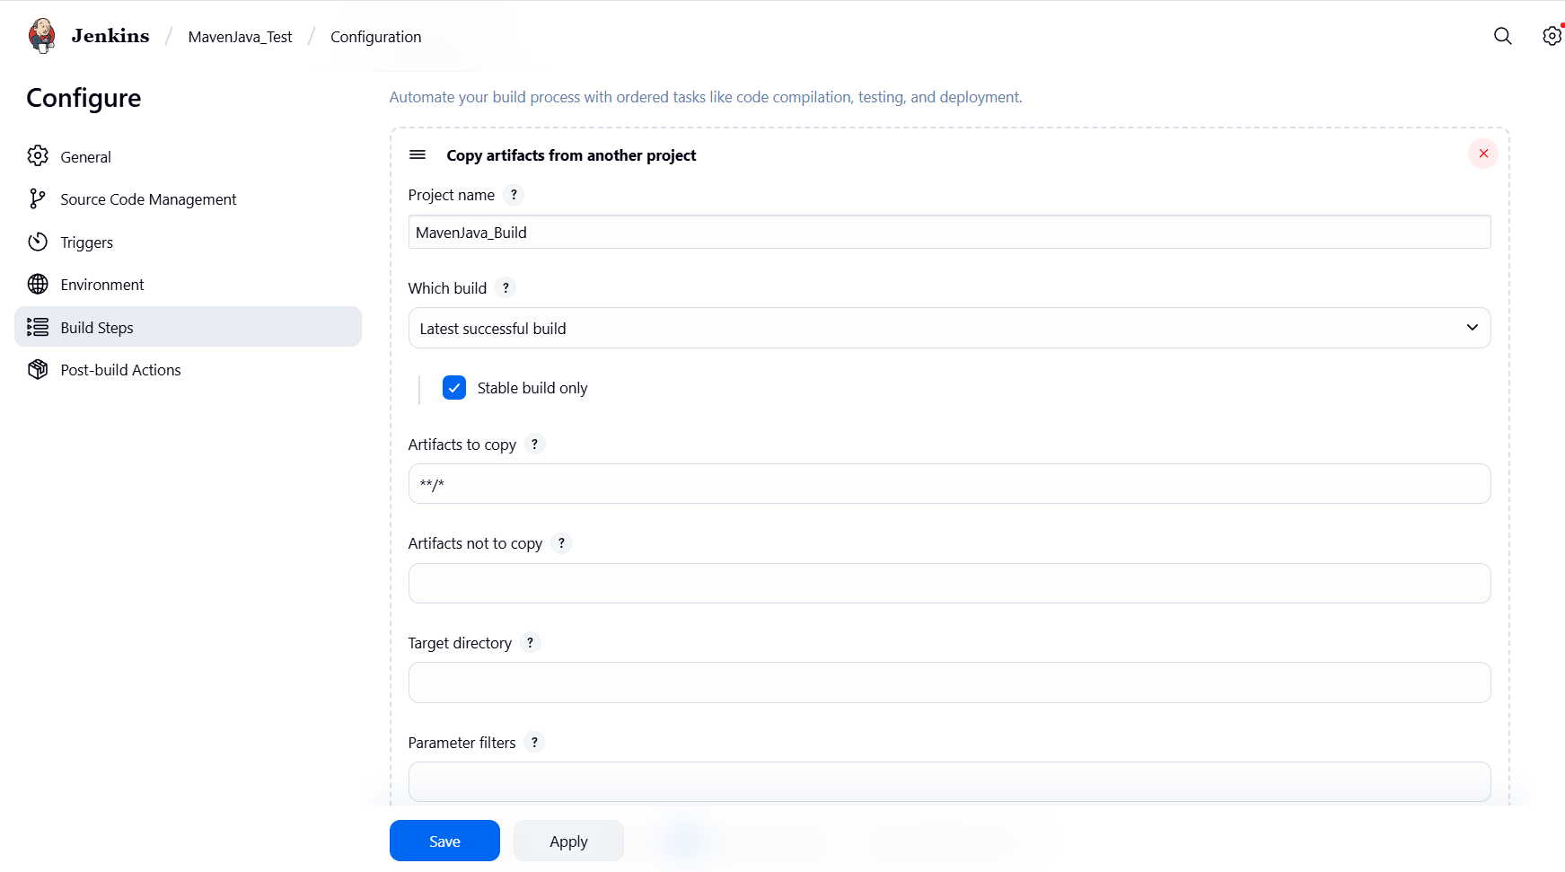
├── Add Post Build Action -> "Build other projects"
└── Projects to build: MavenJava_Test
└── Trigger: Only if build is stable
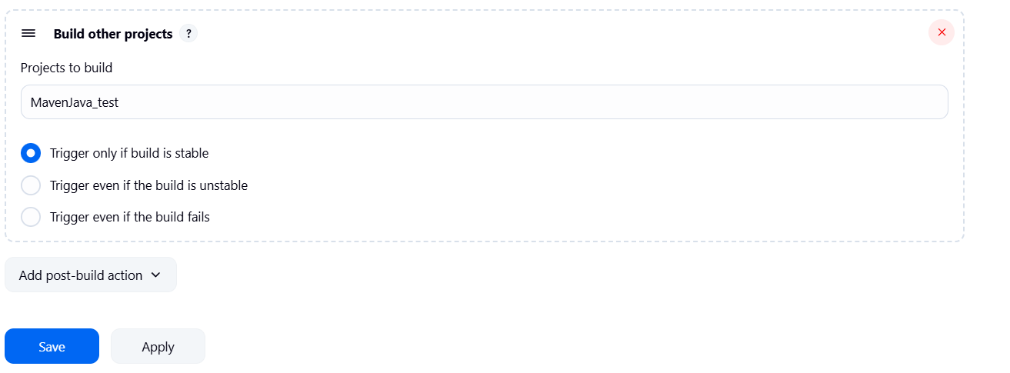
└── Apply and Save

└── Step 3: Create Freestyle Project (e.g., MavenJava_Test)
├── Enter project name (e.g., MavenJava_Test)
├── Click "OK"
└── Configure the project:
├── Description: "Test demo"
├── Build Environment:
└── Check: "Delete the workspace before build starts"
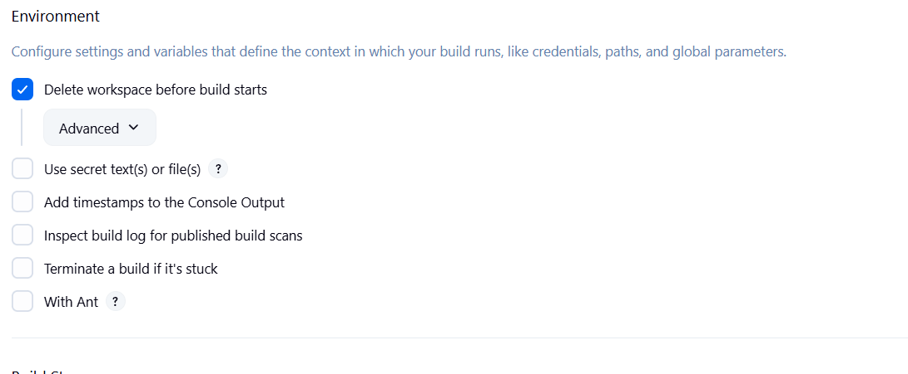
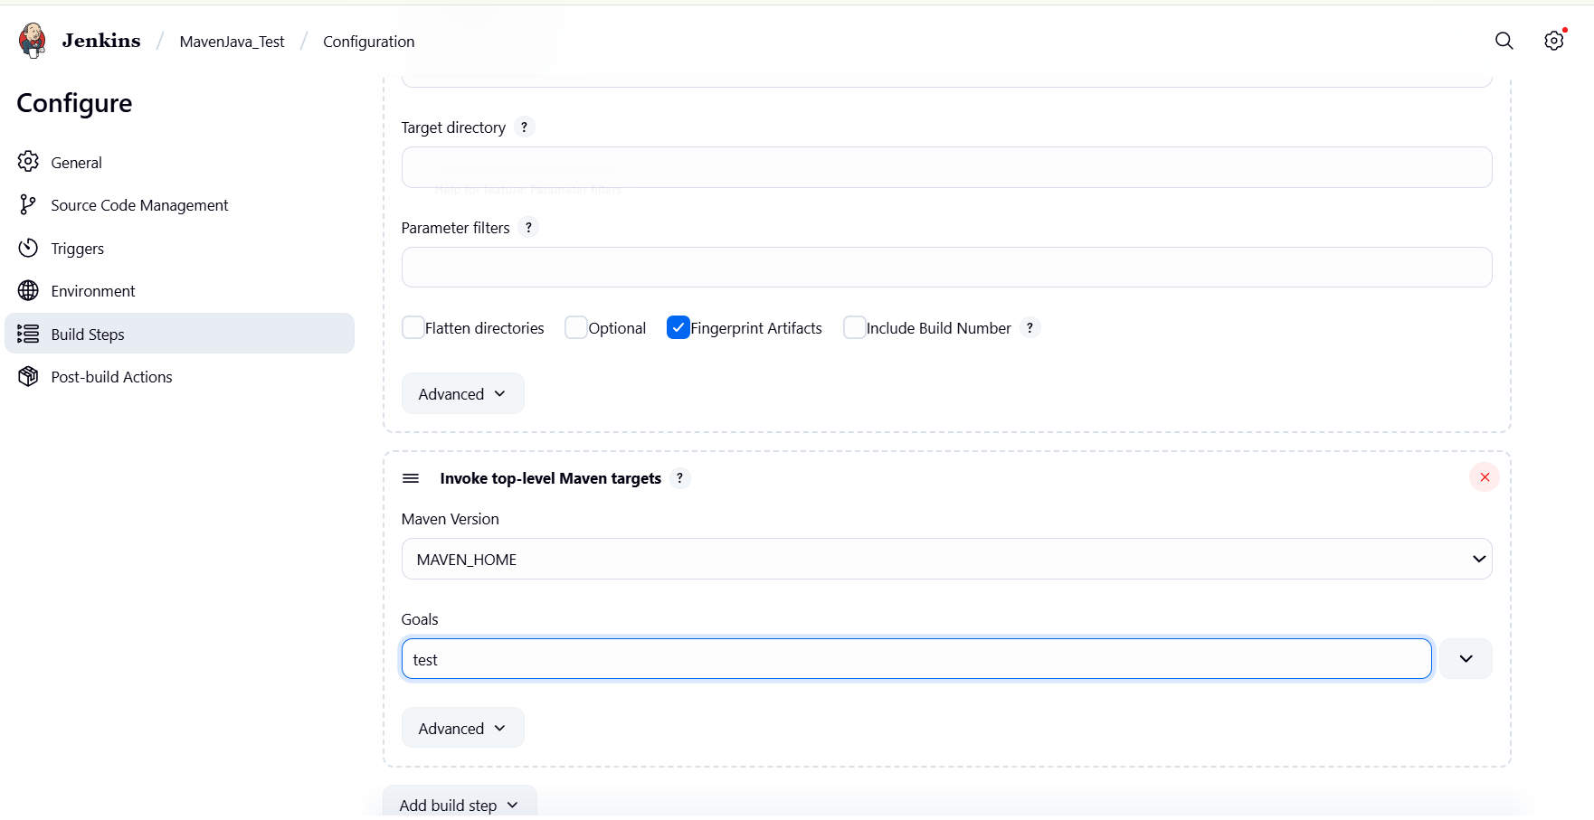
├── Add Build Step -> "Copy artifacts from another project"
└── Project name: MavenJava_Build
└── Build: Stable build only // tick at this
└── Artifacts to copy: **/*
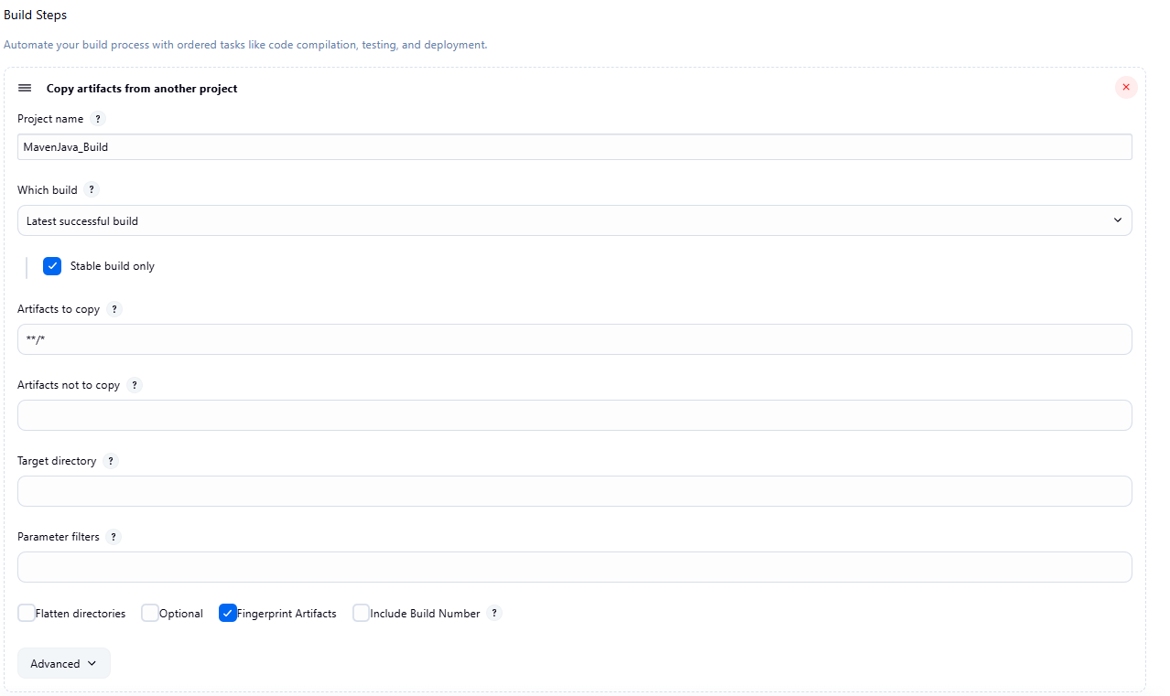
├── Add Build Step -> "Invoke top-level Maven targets"
└── Maven version: MAVEN_HOME
└── Goals: test
└── Post-build Actions:
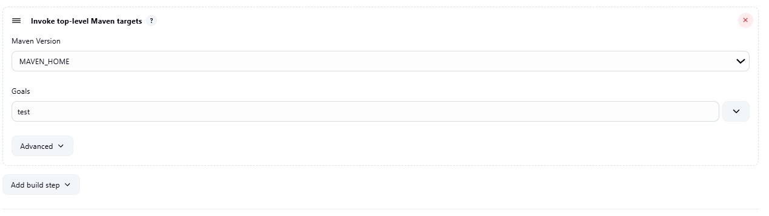
├── Add Post Build Action -> "Archive the artifacts"
└── Files to archive: **/*
└── Apply and Save
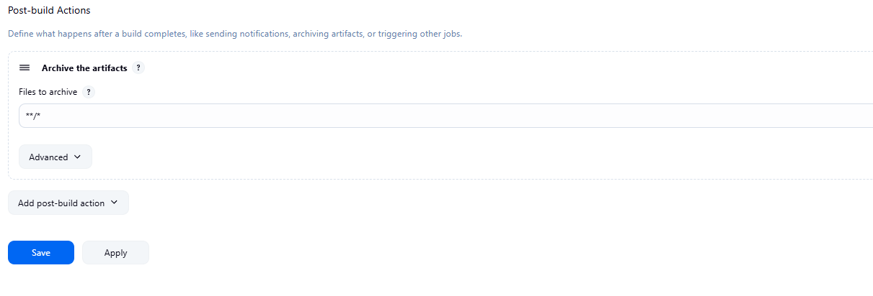

└── Step 4: Create Pipeline View for Maven Java project
├── Click "+" beside "All" on the dashboard
├── Enter name: MavenJava_Pipeline
├── Select "Build pipeline view" // tick here
|--- create
└── Pipeline Flow:
├── Layout: Based on upstream/downstream relationship
├── Initial job: MavenJava_Build
└── Apply and Save OK
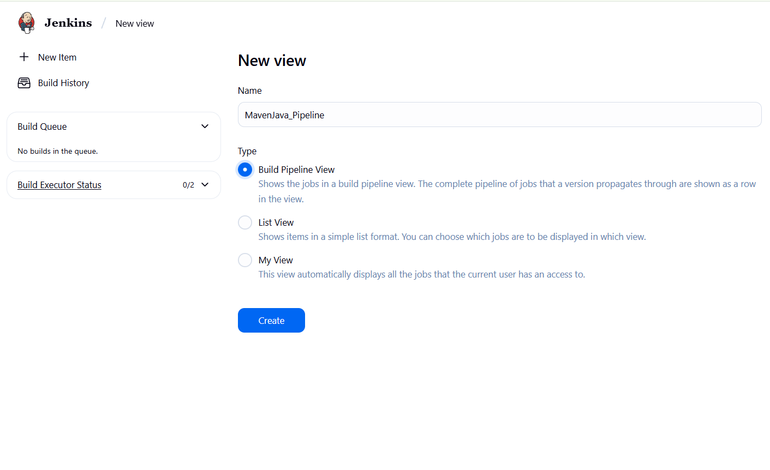

└── Step 5: Run the Pipeline and Check Output
├── Click on the trigger to run the pipeline
├── click on the small black box to open the console to check if the build is success
Note :
- If build is success and the test project is also automatically triggered with name
“MavenJava_Test”
- The pipeline is successful if it is in green color as shown ->check the console of the test project
- The test project is successful and all the artifacts are archived successfully
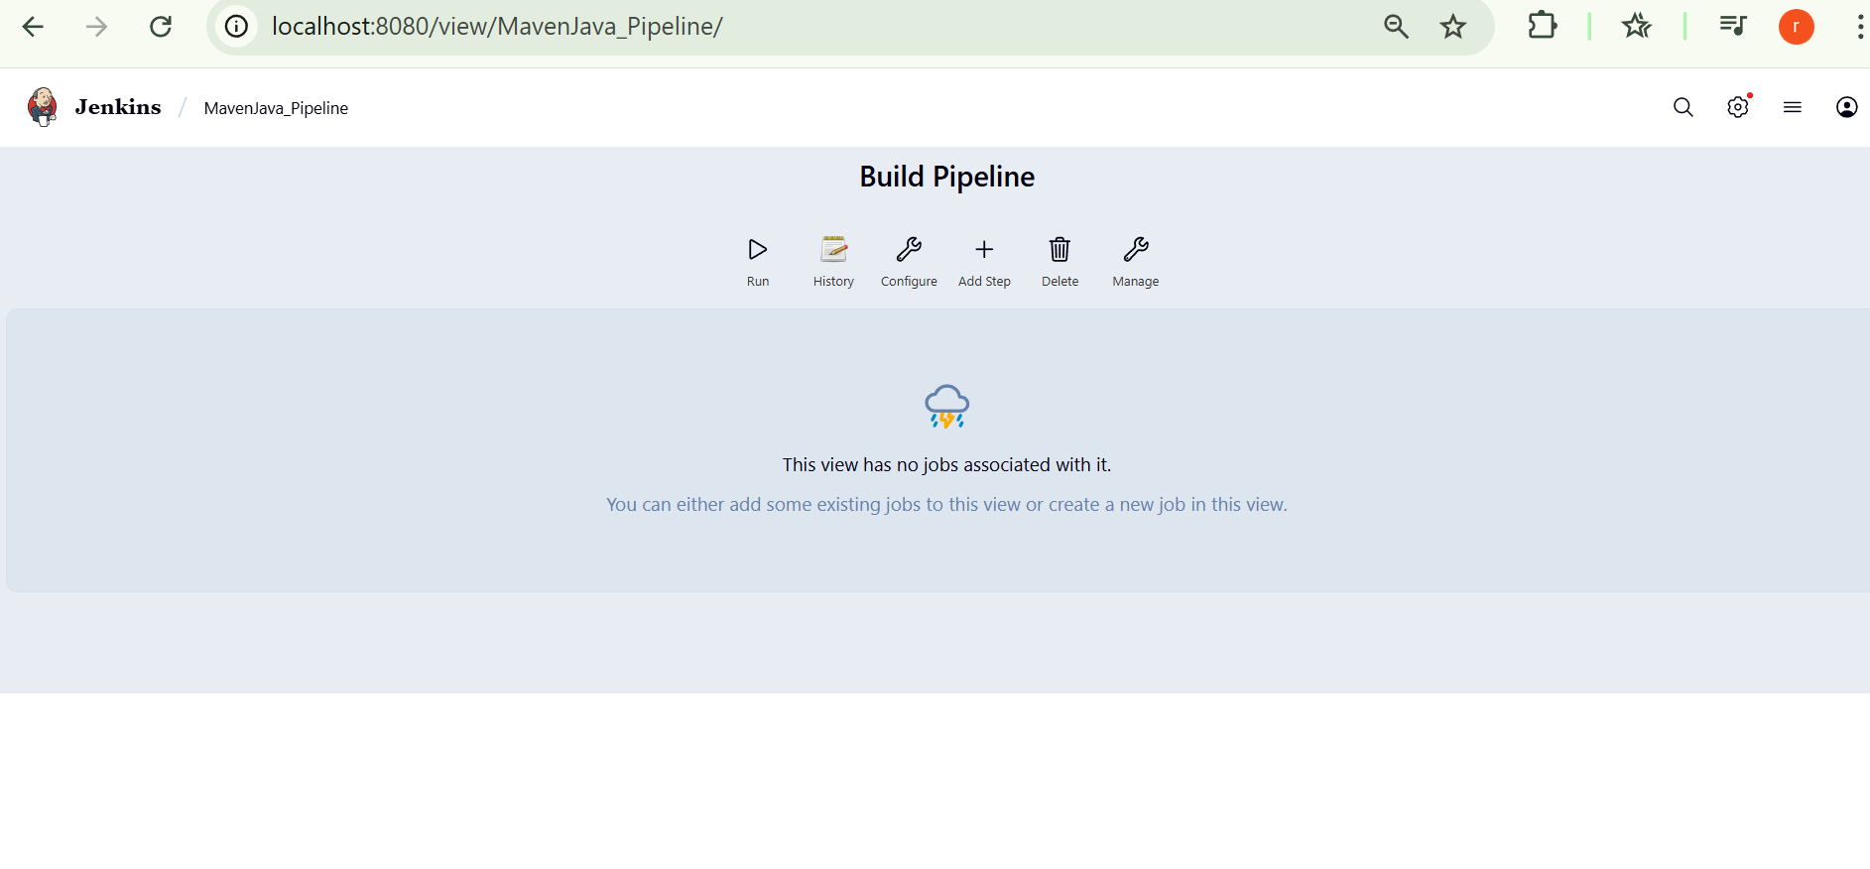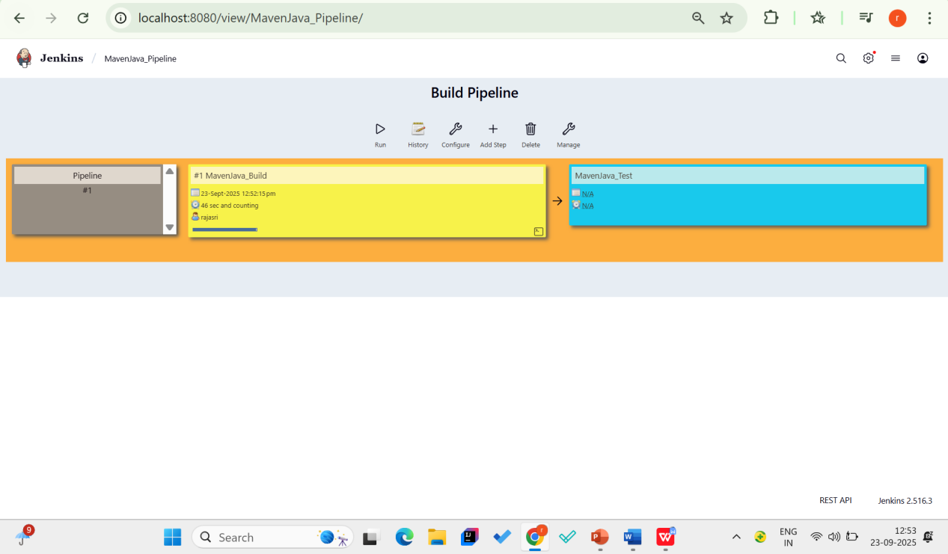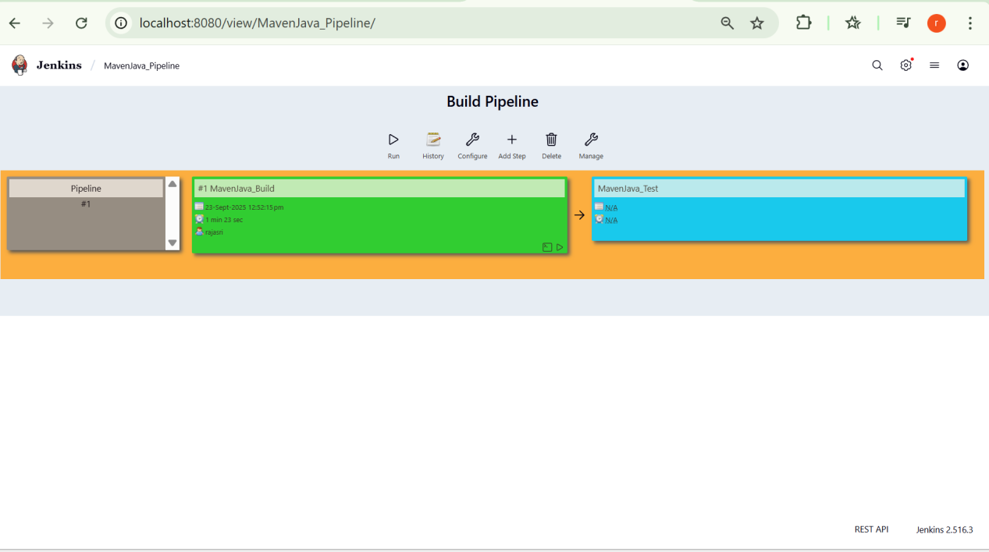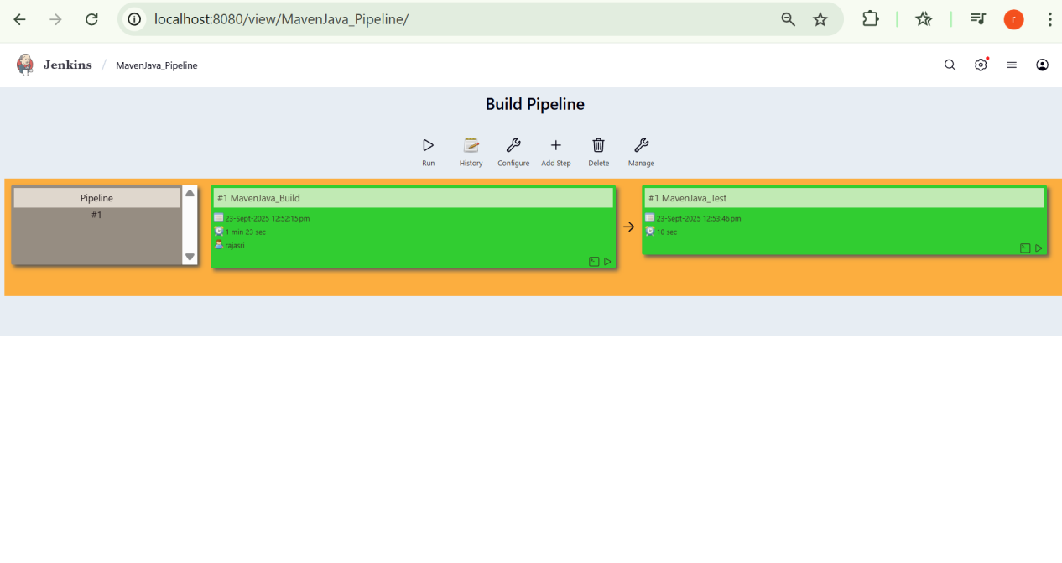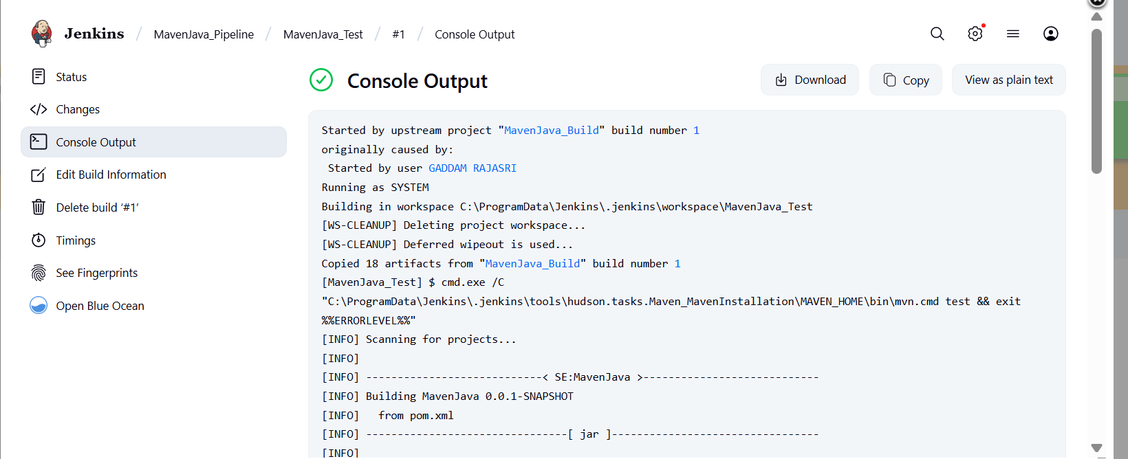

Started by upstream project "MavenJava_Build" build number 6
originally caused by:
Started by user GADDAM RAJASRI
Running as SYSTEM
Building in workspace C:\ProgramData\Jenkins\.jenkins\workspace\MavenJava_Test
[WS-CLEANUP] Deleting project workspace...
[WS-CLEANUP] Deferred wipeout is used...
[WS-CLEANUP] Done
Copied 18 artifacts from "MavenJava_Build" build number 6
[MavenJava_Test] $ cmd.exe /C "C:\ProgramData\Jenkins\.jenkins\tools\hudson.tasks.Maven_MavenInstallation\MAVEN_HOME\bin\mvn.cmd test && exit %%ERRORLEVEL%%"
[INFO] Scanning for projects...
[INFO]
[INFO] ----------------------------< SE:MavenJava >----------------------------
[INFO] Building MavenJava 0.0.1-SNAPSHOT
[INFO] from pom.xml
[INFO] --------------------------------[ jar ]---------------------------------
[INFO]
[INFO] --- resources:3.3.1:resources (default-resources) @ MavenJava ---
[INFO] skip non existing resourceDirectory C:\ProgramData\Jenkins\.jenkins\workspace\MavenJava_Test\src\main\resources
[INFO]
[INFO] --- compiler:3.13.0:compile (default-compile) @ MavenJava ---
[INFO] Recompiling the module because of added or removed source files.
[INFO] Compiling 1 source file with javac [debug release 17] to target\classes
[INFO]
[INFO] --- resources:3.3.1:testResources (default-testResources) @ MavenJava ---
[INFO] skip non existing resourceDirectory C:\ProgramData\Jenkins\.jenkins\workspace\MavenJava_Test\src\test\resources
[INFO]
[INFO] --- compiler:3.13.0:testCompile (default-testCompile) @ MavenJava ---
[INFO] Recompiling the module because of changed dependency.
[INFO] Compiling 1 source file with javac [debug release 17] to target\test-classes
[INFO]
[INFO] --- surefire:3.3.0:test (default-test) @ MavenJava ---
[INFO] Using auto detected provider org.apache.maven.surefire.junitplatform.JUnitPlatformProvider
[INFO]
[INFO] -------------------------------------------------------
[INFO] T E S T S
[INFO] -------------------------------------------------------
[INFO] Running SE.MavenJava.AppTest
[INFO] Tests run: 1, Failures: 0, Errors: 0, Skipped: 0, Time elapsed: 0.109 s -- in SE.MavenJava.AppTest
[INFO]
[INFO] Results:
[INFO]
[INFO] Tests run: 1, Failures: 0, Errors: 0, Skipped: 0
[INFO]
[INFO] ------------------------------------------------------------------------
[INFO] BUILD SUCCESS
[INFO] ------------------------------------------------------------------------
[INFO] Total time: 9.425 s
[INFO] Finished at: 2025-09-25T14:24:00+05:30
[INFO] ------------------------------------------------------------------------
Archiving artifacts
Finished: SUCCESS

II. Maven Web Automation Steps:
└── Step 1: Open Jenkins (localhost:8080)
├── Click on "New Item" (left side menu)

└── Step 2: Create Freestyle Project (e.g., MavenWeb_Build)
├── Enter project name (e.g., MavenWeb_Build)
├── Click "OK"
└── Configure the project:
├── Description: "Web Build demo"
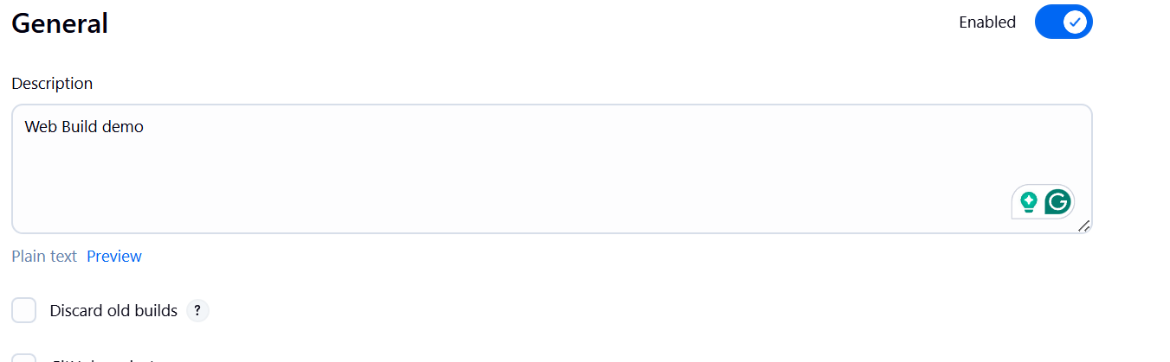
├── Source Code Management:
└── Git repository URL: [GitMavenWeb repo URL]
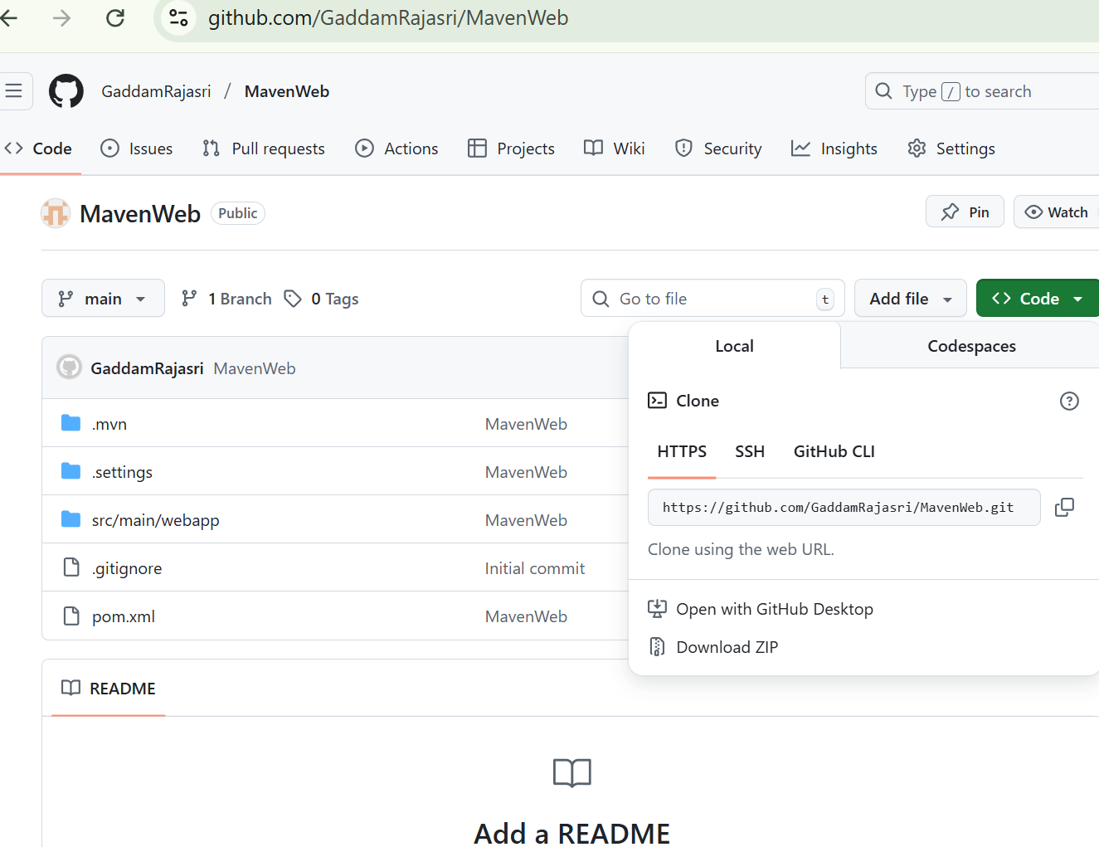
├── Branches to build: */Main or master
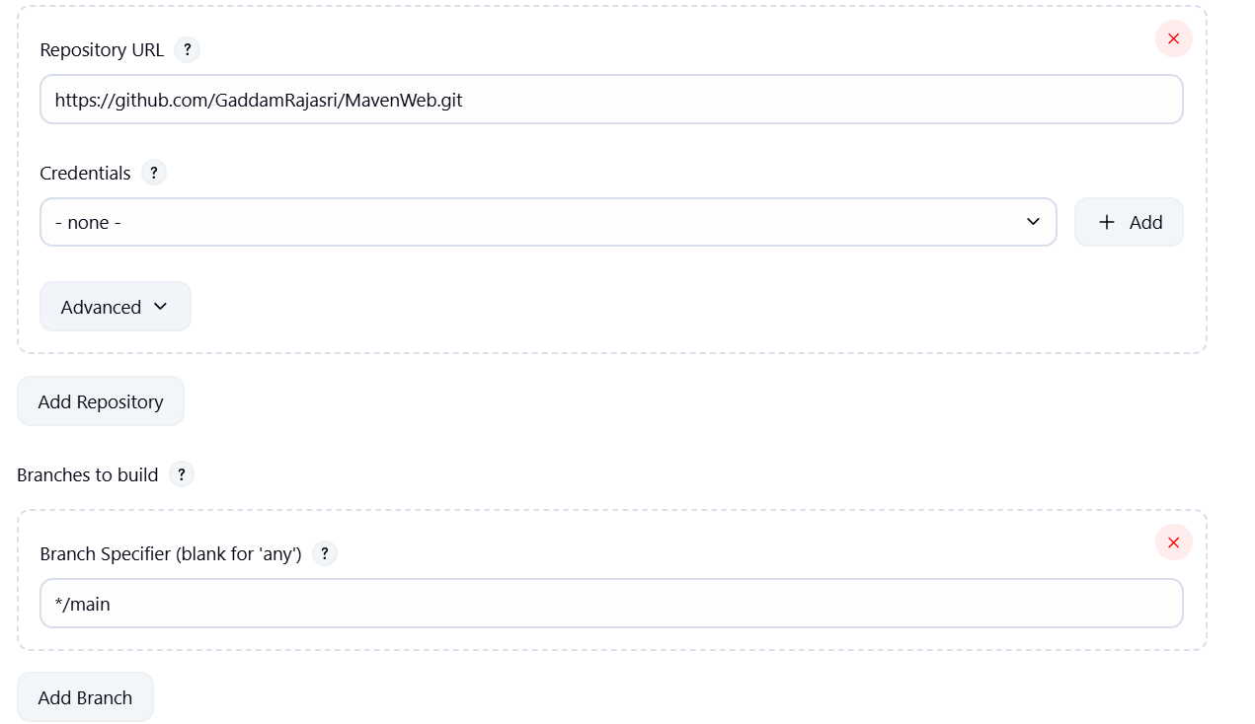
└── Build Steps:
├── Add Build Step -> "Invoke top-level Maven targets"
└── Maven version: MAVEN_HOME
└── Goals: clean
├── Add Build Step -> "Invoke top-level Maven targets"
└── Maven version: MAVEN_HOME
└── Goals: install
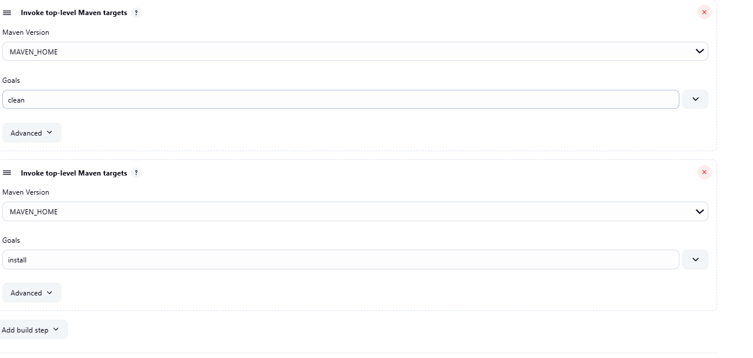
└── Post-build Actions:
├── Add Post Build Action -> "Archive the artifacts"
└── Files to archive: **/*
├── Add Post Build Action -> "Build other projects"
└── Projects to build: MavenWeb_Test
└── Trigger: Only if build is stable
└── Apply and Save
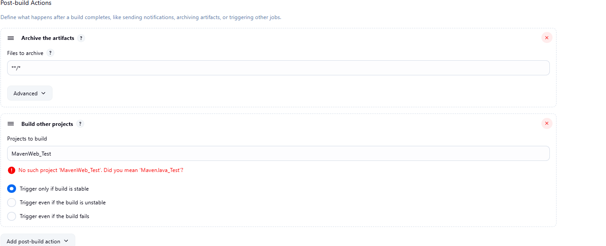

└── Step 3: Create Freestyle Project (e.g., MavenWeb_Test)
├── Enter project name (e.g., MavenWeb_Test)
├── Click "OK"
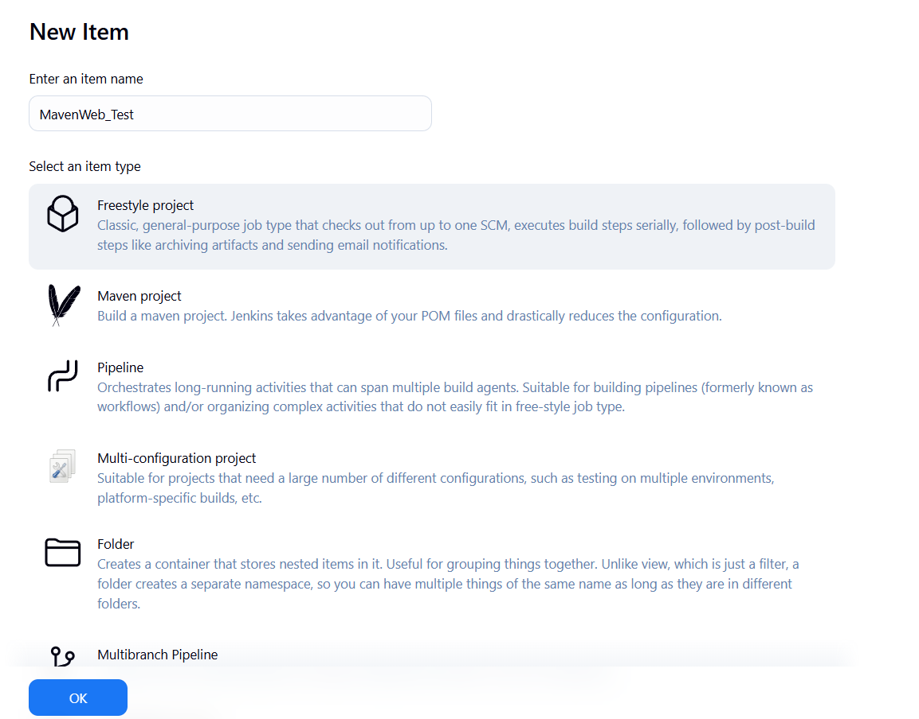
└── Configure the project:
├── Description: "Test demo"
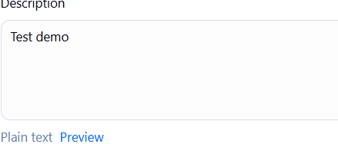
├── Build Environment:
└── Check: "Delete the workspace before build starts"
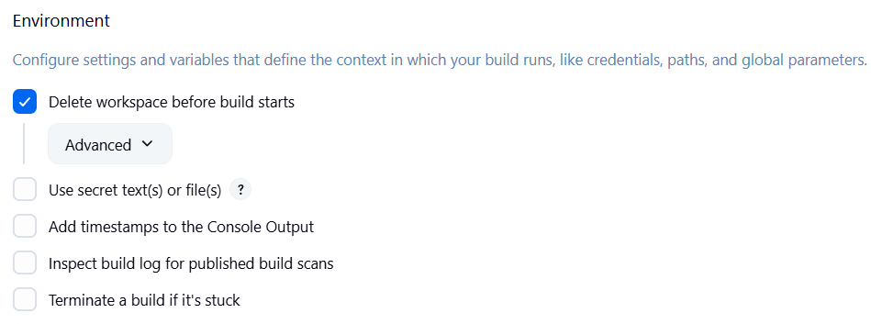
├── Add Build Step -> "Copy artifacts from another project"
└── Project name: MavenWeb_Build
└── Build: Stable build only
└── Artifacts to copy: **/*
├── Add Build Step -> "Invoke top-level Maven targets"
└── Maven version: MAVEN_HOME
└── Goals: test
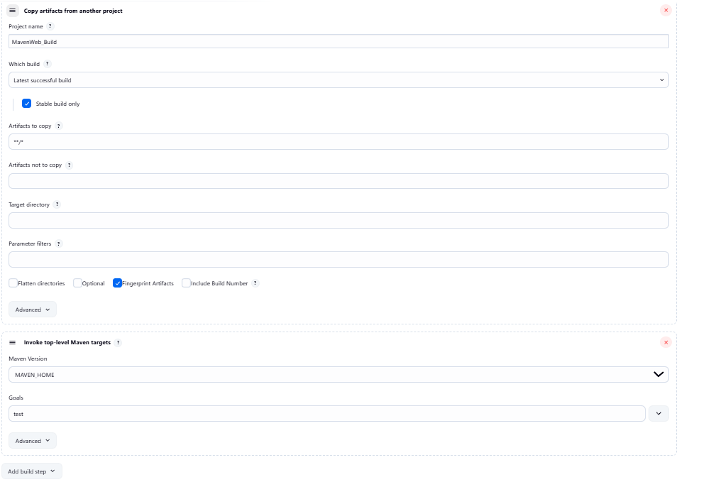
└── Post-build Actions:
├── Add Post Build Action -> "Archive the artifacts"
└── Files to archive: **/*
├── Add Post Build Action -> "Build other projects"
└── Projects to build: MavenWeb_Deploy
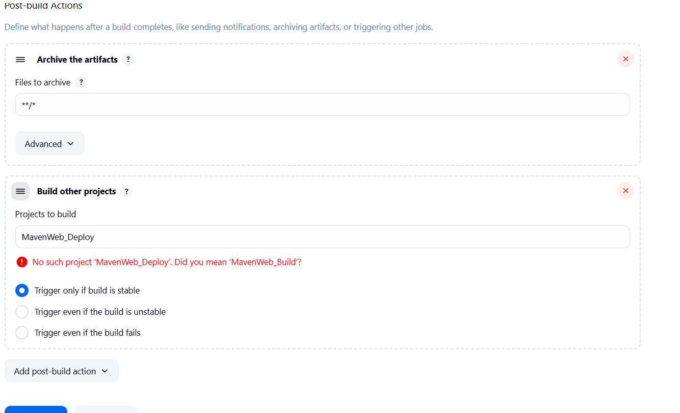
└── Apply and Save

└── Step 4: Create Freestyle Project (e.g., MavenWeb_Deploy)
├── Enter project name (e.g., MavenWeb_Deploy)
├── Click "OK"
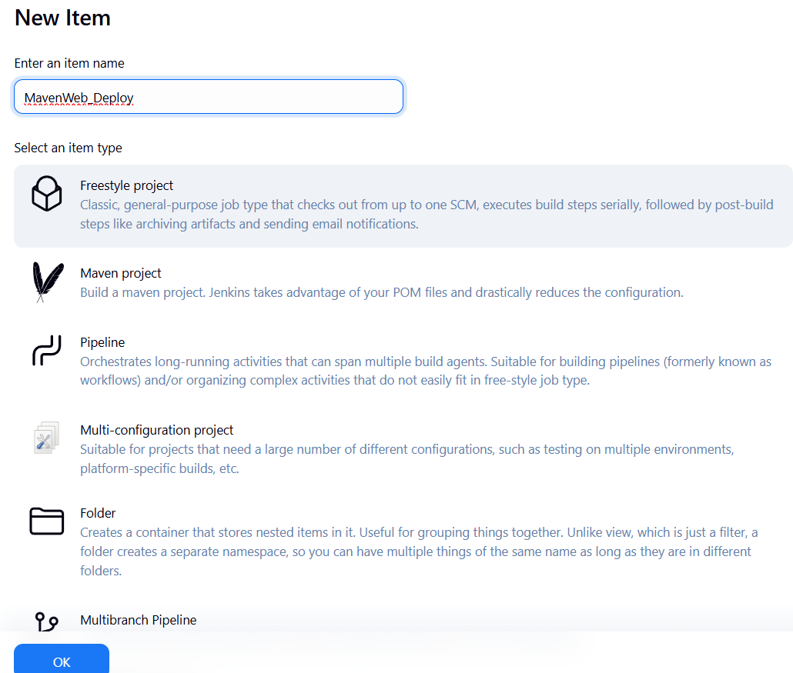
└── Configure the project:
├── Description: "Web Code Deployment"
├── Build Environment:
└── Check: "Delete the workspace before build starts"
├── Add Build Step -> "Copy artifacts from another project"
└── Project name: MavenWeb_Test
└── Build: Stable build only
└── Artifacts to copy: **/*
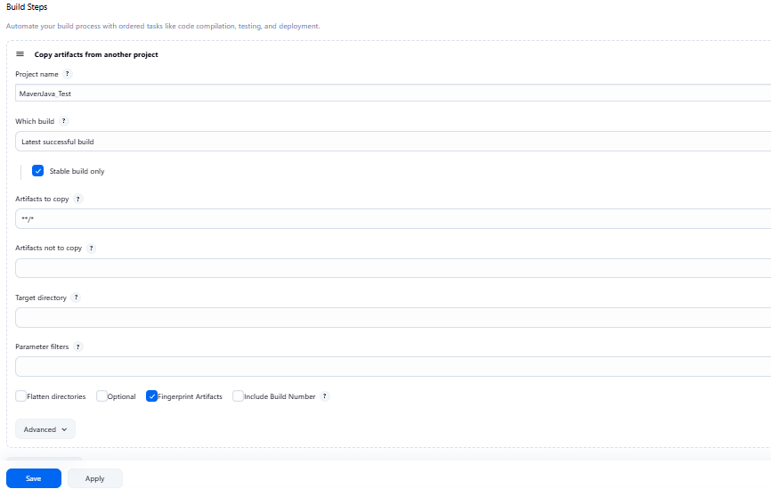
└── Post-build Actions:
├── Add Post Build Action -> "Deploy WAR/EAR to a container"
└── WAR/EAR File: **/*.war
└── Context path: Webpath
└── Add container -> Tomcat 9.x remote
└── Credentials: Username: admin, Password: 1234
── Tomcat URL: https://localhost:8085/
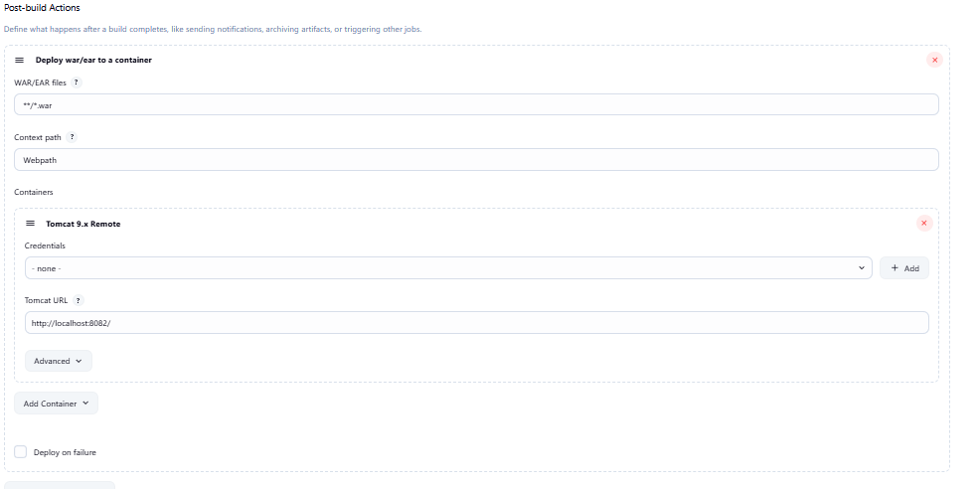
└── Apply and Save

└── Step 5: Create Pipeline View for MavenWeb
├── Click "+" beside "All" on the dashboard
├── Enter name: MavenWeb_Pipeline
├── Select "Build pipeline view"
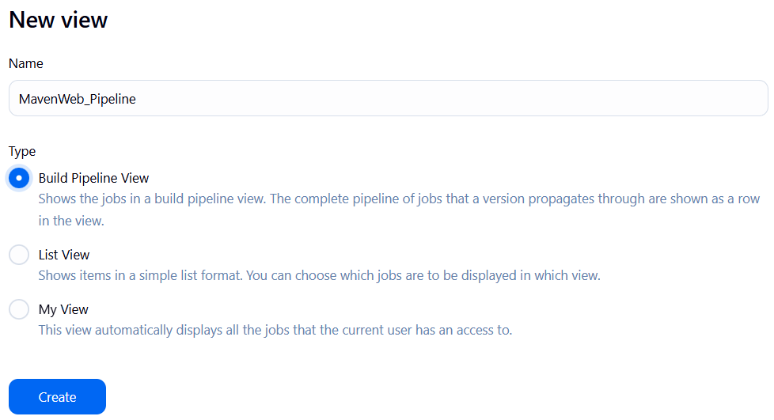
└── Pipeline Flow:
├── Layout: Based on upstream/downstream relationship
├── Initial job: MavenWeb_Build
└── Apply and Save

└── Step 6: Run the Pipeline and Check Output
├── Click on the trigger “RUN” to run the pipeline

Note:
- After Click on Run -> click on the small black box to open the console to check if the build is success
- Now we see all the build has success if it appears in green color
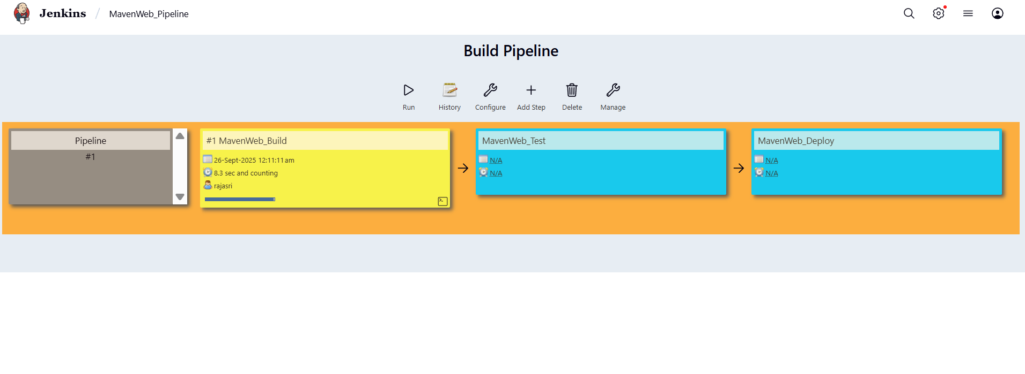
├── Open Tomcat homepage in another tab
├── Click on the "/webpath" option under the manager app
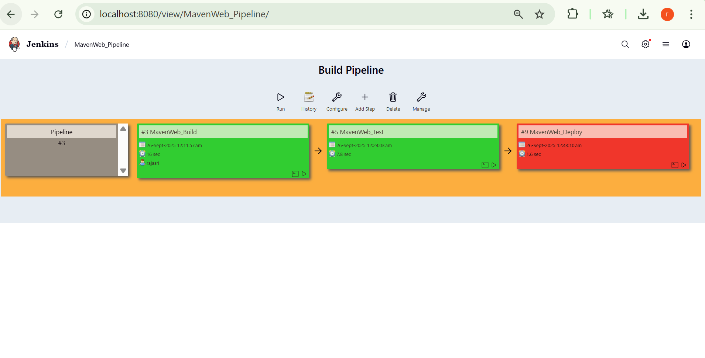
Note:
- It ask for user credentials for login ,provide the credentials of tomcat.
- It provide the page with out project name which is highlighted.
- After clicking on our project we can see output.

- Questions on Jenkins
1.What is Jenkins primarily used for?
Ans: Jenkins is primarily used for Continuous Integration (CI) and Continuous Delivery/Deployment (CD). It automates the building, testing, and deploying of applications to streamline the software development lifecycle.

- What is feature of Jenkins?
Ans: Open-source and extensible.
• Huge plugin ecosystem (>1800 plugins).
• Supports distributed builds on multiple nodes.
• Easy integration with tools like Git, Maven, Docker, Kubernetes.
• Provides pipelines (scripted and declarative).

- What is the default port on which Jenkins runs?
Ans: 8080
- What can be integrated with Jenkins for version control?
Ans: Git (most common)
• SVN (Subversion)
• Mercurial
• Bitbucket / GitHub / GitLab

- What is the purpose of Jenkins plugins?
Ans: Plugins extend Jenkins functionality. They allow integration with external tools, add build steps, SCM support, pipeline features, reporting, and deployment capabilities.
- Which type of Jenkins job is best suited for running one-off tasks or small script?
Ans: Freestyle Job
It’s simple and quick for small tasks like running shell scripts or testing basic builds.
- How can you manage sensitive information such as API keys in Jenkins?
Ans: Use Jenkins Credentials Plugin (stores secrets securely).
Bind credentials in Pipeline with withCredentials{} block.
Avoid hardcoding secrets in Jenkinsfiles or jobs.
- What does the "blue ocean" feature in Jenkins refer to?
Ans: Blue Ocean is a modern, user-friendly UI for Jenkins that provides:
- Visual representation of pipelines.
- Simplified navigation and better UX.
- Clearer visualization of pipeline stages and failures.
- What does the "blue ocean" feature in Jenkins refer to?
Ans: It is Jenkins’ modern UI for pipelines.
- Which Jenkins component allows for distributed builds across multiple machines?
Ans: Jenkins Master-Agent (Node) Architecture
- Master schedules and manages jobs.
- Agents (nodes/slaves) execute jobs.
- List at least five Jenkins plugins that you would consider important for a microservices-based application CI/CD pipeline. Briefly explain the purpose of each plugin.
Ans: Git Plugin – integrates Jenkins with Git for SCM.
• Pipeline Plugin – enables writing complex build/deploy workflows as code.
• Docker Plugin – builds and manages Docker containers for microservices.
• Kubernetes Plugin – runs Jenkins agents inside Kubernetes pods dynamically.
• SonarQube Plugin – integrates static code analysis for code quality checks.
(Other useful ones: Artifactory, Slack Notifications, JUnit, Maven Integration).
- Explain the steps you would take to install a plugin in Jenkins through the Jenkins UI. What considerations would you keep in mind regarding plugin compatibility and updates?
- Ans: Go to Manage Jenkins → Manage Plugins.
- Search plugin under Available tab.
- Select and click Install without restart (or with restart).
- Verify under Installed plugins.
Considerations:
- Check compatibility with Jenkins core version.
- Review dependencies (some plugins need others).
- Prefer LTS Jenkins + stable plugin versions.
- Always test in staging Jenkins before production.
- Explain the steps you would take to install a plugin in Jenkins through the Jenkins UI. What considerations would you keep in mind regarding plugin compatibility and updates?
- Ans: Go to Manage Jenkins → Manage Plugins.
- Search plugin under Available tab.
- Select and click Install without restart (or with restart).
- Verify under Installed plugins.
Considerations:
- Check compatibility with Jenkins core version.
- Review dependencies (some plugins need others).
- Prefer LTS Jenkins + stable plugin versions.
- Always test in staging Jenkins before production.
- After installing a plugin, explain how you would configure it within Jenkins. For example, if you installed the Git Plugin, what steps would you take to set it up for your pipeline?
Ans: Go to Manage Jenkins → Global Tool Configuration.
• Under Git, set path to Git executable or let Jenkins install it automatically.
• (Optional) Configure credentials (GitHub/Bitbucket) in Manage Credentials.
• In a Pipeline/Freestyle job, select Git SCM and provide repo URL + credentials.
- Discuss common issues that might arise when using Jenkins plugins, such as dependency conflicts or version compatibility problems. How would you troubleshoot these issues?
Ans: • Dependency conflicts → Some plugins depend on specific versions of others.
🔹 Fix: Upgrade/downgrade conflicting plugins, check plugin documentation.
• Version incompatibility with Jenkins core → New plugin may not support your Jenkins version.
🔹 Fix: Upgrade Jenkins core or use an older plugin version.
• Security vulnerabilities → Outdated plugins may have CVEs.
🔹 Fix: Regularly update plugins and monitor Jenkins advisories.
• Pipeline errors after plugin update → Syntax/behavior changes.
🔹 Fix: Check plugin changelogs, adjust Jenkinsfile accordingly.
• Plugins failing to load after restart → Corrupt plugin cache.
🔹 Fix: Remove the .jpi and .jpi.pinned files from $JENKINS_HOME/plugins/ and reinstall
Conclusion: In this week student learnt automating Maven projects through Jenkins.

